# Acceptance Criteria Testing

## Story ID 7

## As the driver I want to be able to see individual delivery details for each package so that I deliver it to the correct place and the correct person receives it.

* I can see detailed information about each delivery
  + Name/company of receiver, address, priority, signature required and authority to leave are provided with each order.
  + I can see a map of the delivery location.

I can see detailed information about each delivery

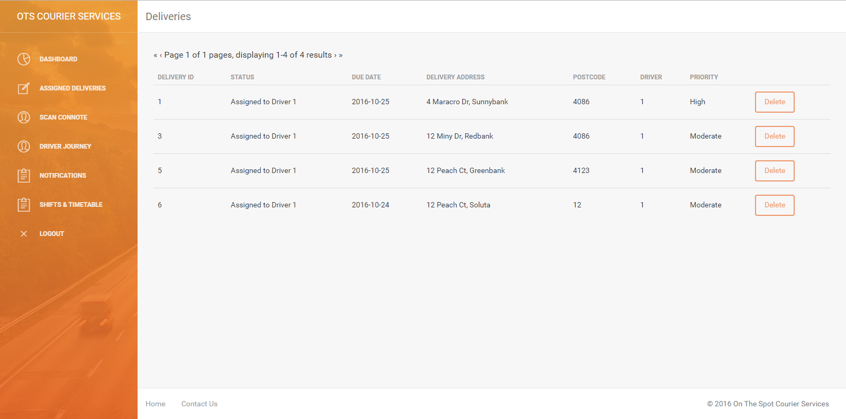

NOT IMPLEMENTED → Name/Company of receiver, signature and authority

These values were not implemented where deliveries were put into the database and in the end after discussion were not considered worthwhile to include.

NOT IMPLEMENTED → Map of delivery location

During development this feature was considered low priority and was not implemented.